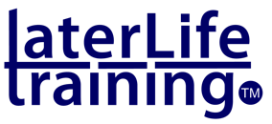
Workforce development for
Wellbeing and Active Ageing

To assist your thinking about your proposed workforce development, take a few moments to consider and clarify the following:

Purpose: What do you want your programme to achieve and what benefits will workforce participants get from being involved?

Target population(s): Who are the intended targets or recipients of any programme or intervention and what benefits do you want them to feel?

Your workforce: Describe the workforce that you want to be involved (roles and practice) and what you expect them to be able to do as a result?

Starting from strength: Outline previous/current experience of wellbeing and physical activity work within your service(s).

Implementation: How will the new learning (knowledge, skills and understanding) be applied and supported in practice?

What would success look and feel like for your workforce?

Your Email:
Your telephone:

For an initial discussion about your workforce planning needs in Wellbeing and Active Ageing, please forward to and contact Bob Laventure at bob.laventure@laterlifetraining.co.uk

